SYSTEM REQUIRMENT SPECIFICATIONS FOR

Mighty Business

PURPOSE OF THE SYSTEM

In every context, Business plays a vital role in the part of human life. Business is nothing but transaction of goods between people. Business is a flow of so many processes ranging from procuring goods to correct delivery of finished products. A trading product reaches the ultimate consumer. This project mainly concerns about management of procuring goods, which is a main part of trading system. Successful trading allows an enterprise to anticipate demand and deliver the right product to the right place at the right time at the lowest possible cost to satisfy its customers. The project entitled Indian Deals is useful for negotiations between trading partners of a company.

This thesis mainly concerns in passing messages between Buyer and Supplier companies. Here, Buyer Company creates purchase order according to their requirements and sends to Supplier Company. On receiving the PO the Supplier Company give response to it. If Supplier company meets the requirements that are specified in PO then its sends confirmation to Buyer otherwise proposal satisfies the requirements of the Buyer Company it accepts otherwise rejects.

The above describes the main process of the project. In addition to this, we have search option where we can see all the PO's and their status i.e. whether they are read, responded or non-responded by Supplier. In this thesis, the role of administrator is that he can add a new company, which has the summary of PO’s, which they have sent and receive by just check on them.

Features

- Negotiations between Buyer and Supplier Company.
- Immediate data transfer among trading partners.
- Can view PO's information.

PROBLEMS IN THE EXISTING SYSTEM

- This main concern in passing messages between Buyer and Supplier companies.
- Here, Buyer Company creates purchase order according to their requirements and sends to Supplier Company.
- On receiving the PO the Supplier Company give response to it.
- If Supplier company meets the requirements which are specified in PO then its sends confirmation to Buyer otherwise proposal satisfies the requirements of the Buyer Company it accepts otherwise rejects.

SOLUTION OF THESE PROBLEMS

- Negotiations between Buyer and Supplier Company.
- Immediate data transfer among trading partners.
- Can view PO's information.

STUDY OF THE SYSTEM

In the flexibility of the uses the interface has been developed a graphics concept in mind, associated through a browses interface. The G U I’S at the top level have been categorized as
- Administrative user interface
- The operational or generic user interface

The administrative user interface concentrates on the consistent information that is practically, part of the organizational activities and which needs proper authentication for the data collection. The interfaces help the administrations with all the transactional states like Data insertion, Data deletion and Date updating along with the extensive data search capabilities.

The operational or generic user interface helps the users upon the system in transactions through the existing data and required services. The operational user interface also helps the ordinary users in managing their own information helps the ordinary users in managing their own information in a customized manner as per the assisted flexibilities.

NUMBER OF MODULES

1. Administration Module
- Registration Maintenance Module
- Authentication Module
- Administrative Module
2. Suppliers Module
- Register Module
- Login Module
- Products Module
- Purchase Order Module
3. Buyers Module
- Register Module
- Login Module
- Purchase Order Module
4. Message Module

5. Search Module

Administrator:

- This Modules involves Administrator operations, involves with maintenance registration, authenticating the suppliers and buyers. This Module contains three sub-modules.
- Registration Maintenance Module:-This Modules contains operations that perform registration for new suppliers and buyers. When the supplier or buyer fill-up the registration form with out empty fields, the details of that supplier or buyer can store within the database.
- Authentication Module:-This module authenticated for responsible supplier or user. If any registered supplier or user trying to entering into this system, the administrator check the database if supplier/buyer is existing or no, if exists then checkout the supplier/buyer status in database for allow enter to the system.
- Administrative Module:- This module maintains list of suppliers and list of buyers from databases.

Suppliers Module:
- This Module involves operations involving with a particular supplier.
- Register Module:- This Modules perform registration process of new suppliers and store the given details to database.
- Login Module:- This module checks the entered supplier is exists in database or not. If the supplier is exist then perform administrator authentication module can invoke for permission.
- Products Module:-This module maintains processes on products database such as addition new products, delete existing products etc.,
- Purchase Order Module:-This Module involves in processing the received purchase orders from buyers. This module contains operations to accept, suggestions or rejection of received purchase order.

Buyers Module:

This module contains processes on particular buyer.
Register Module:- This Modules perform registration process of new buyers and store the given details to database.
Login Module: - This module checks the entered buyer is exists in database or not. If the buyer is exist then perform administrator authentication module can invoke for permission.
Purchase Order Module: - This Module involves in processing the Purchase Order operations like Create new Purchase Order, receiving Suggestion from Suppliers, send Confirmation to suppliers etc. This module contains operations to accept suggestions or rejection of received purchase order.

Message Module:
- This module plays main role to establish online communication through this system between buyers, suppliers and administrator.
- This module contains message composition, inbox to display messages and delete specified messages after reading the messages.

Search Module:
- This Module contains operations to perform searching for products, suppliers, buyers whose satisfies particular condition. The buyer module contain

SDLC METHODOLOGY USED
Object Oriented Analysis and Design (OOAD) is the model, chosen to design and develop the proposed system.

Features of OOAD:
- It users Objects as building blocks of the application rather functions
- All objects can be represented graphically including the relation between them.
- All Key Participants in the system will be represented as actors and the actions done by them will be represented as use cases.
- A typical use case is nothing bug a systematic flow of series of events which can be well described using sequence diagrams and each event can be described diagrammatically by Activity as well as state chart diagrams.
- So the entire system can be well described using OOAD model, hence this model is chosen as SDLC model.

INPUT DESIGN

Input design is a part of overall system design. The main objective during the input design is as given below:
- To produce a cost-effective method of input.
- To achieve the highest possible level of accuracy.
- To ensure that the input is acceptable and understood by the user.
INPUT STAGES:
The main input stages before the information gets stored in the database media:
- Data recording
- Data transcription
- Data conversion
- Data verification
- Data control
- Data transmission
- Data validation
- Data correction

OUTPUT DESIGN

Outputs from computer systems are required primarily to communicate the results of processing to users. They are also used to provide a permanent copy of the results for later consultation. The various types of outputs in general are:
- External Outputs, whose destination is outside the organization.
- Internal Outputs whose destination is with in organization and they are the
    - User’s main interface with the computer.
- Operational outputs whose use is purely with in the computer department.
- Interface outputs, which involve the user in communicating directly with

The outputs were needed to be generated as a hard copy and as well as queries to be viewed on the screen. Keeping in view these outputs, the format for the output is taken from the outputs, which are currently being obtained after manual processing. The standard printer is to be used as output media for hard copies.

ARCHITECTURAL FLOW
The current application is being developed by taking the 3-tier architecture as a prototype. The 3-tier architecture is the most common approach used for web applications today. In the typical example of this model, the web browser acts as the client, IIS handles the business logic, and a separate tier MS-SQL Server handles database functions.
Although the 3-tier approach increases scalability and introduces a separation of business logic from the display and database layers, it does not truly separate the application into specialized, functional layers. For prototype or simple web applications, the 3-tier architecture may be sufficient. However, with complex demands placed on web applications, a 3-tiered approach falls short in several key areas, including flexibility and scalability. These shortcomings occur mainly because the business logic tier is still too broad- it has too many functions grouped into one tier that could be separated out into a finer grained model.

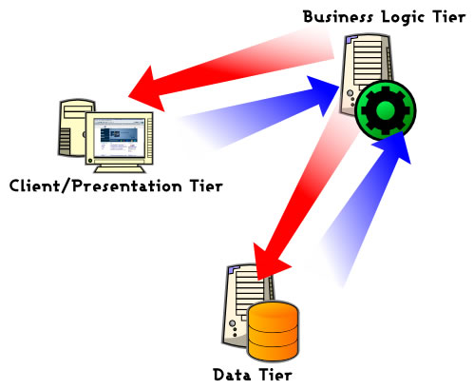

The proposed system can be designed perfectly with the three tier model, as all layers are perfectly getting set as part of the project. In the future, while expanding the system, in order to implement integration touch points and to provide enhanced user interfaces, the n-tier architecture can be used. The following diagram will represent the typical n-tier architecture.

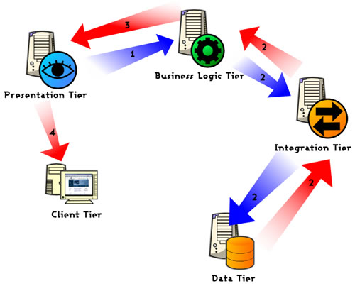

CONTEXT LEVEL DFD

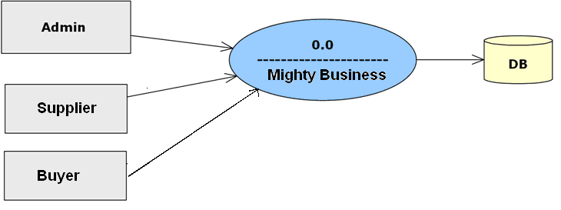

FEASIBILITY STUDY:

Preliminary investigation examine project feasibility, the likelihood the system will be useful to the organization. The main objective of the feasibility study is to test the Technical, Operational and Economical feasibility for adding new modules and debugging old running system. All system is feasible if they are unlimited resources and infinite time. There are aspects in the feasibility study portion of the preliminary investigation:
- Technical Feasibility
- Operation Feasibility
- Economical Feasibility

Technical Feasibility
The technical issue usually raised during the feasibility stage of the investigation includes the following:
- Does the necessary technology exist to do what is suggested?
- Do the proposed equipments have the technical capacity to hold the data required to use the new system?
- Will the proposed system provide adequate response to inquiries, regardless of the number or location of users?
- Can the system be upgraded if developed?
- Are there technical guarantees of accuracy, reliability, ease of access and data security?
Earlier no system existed to cater to the needs of ‘Secure Infrastructure Implementation System’. The current system developed is technically feasible. It is a web based user interface for audit workflow at NIC-CSD. Thus it provides an easy access to the users. The database’s purpose is to create, establish and maintain a workflow among various entities in order to facilitate all concerned users in their various capacities or roles. Permission to the users would be granted based on the roles specified. Therefore, it provides the technical guarantee of accuracy, reliability and security. The software and hard requirements for the development of this project are not many and are already available in-house at NIC or are available as free as open source. The work for the project is done with the current equipment and existing software technology. Necessary bandwidth exists for providing a fast feedback to the users irrespective of the number of users using the system.

Operational Feasibility
Proposed projects are beneficial only if they can be turned out into information system. That will meet the organization’s operating requirements. Operational feasibility aspects of the project are to be taken as an important part of the project implementation. Some of the important issues raised are to test the operational feasibility of a project includes the following: -
- Is there sufficient support for the management from the users?
- Will the system be used and work properly if it is being developed and implemented?
- Will there be any resistance from the user that will undermine the possible application benefits?
This system is targeted to be in accordance with the above-mentioned issues. Beforehand, the management issues and user requirements have been taken into consideration. So there is no question of resistance from the users that can undermine the possible application benefits.
The well-planned design would ensure the optimal utilization of the computer resources and would help in the improvement of performance status.

Economic Feasibility
A system can be developed technically and that will be used if installed must still be a good investment for the organization. In the economical feasibility, the development cost in creating the system is evaluated against the ultimate benefit derived from the new systems. Financial benefits must equal or exceed the costs. The system is economically feasible. It does not require any addition hardware or software. Since the interface for this system is developed using the existing resources and technologies available at NIC, There is nominal expenditure and economical feasibility for certain.

